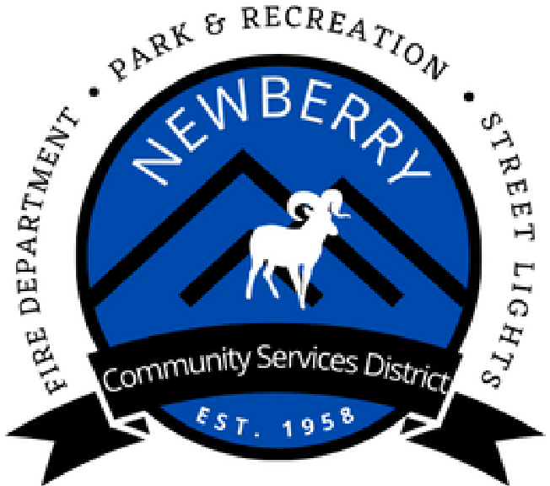
760-257-3613
Newberrycsd.net
30884
Newberry Rd.
Newberry Springs, CA 92365
P.O. Box 220
Newberrycsd@gmail.com

General Manager Report February 24, 2026

- Cadiz Committee Draft MOU- I spoke with our attorney, and his suggestion was to have the committee do some more work on the draft MOU before he reviews it to help keep our cost down. Once the MOU is ready for legal review, I will forward it to David and report back to the Board.
- National Park Service – I have sent Carlos an email requesting immediate delivery of our final documents, my next step will be contacting his boss again and filing a formal complaint if necessary. As you know we have been waiting for the final documents for about a year now and I have made it clear to Carlos that our district is out of patience.
- SDRMA Workers Comp Quote- I am working on the application and had to provide a detailed 10-year loss report to SDRMA from our current Workers Comp. provider. The application will then be sent to their underwriting team for review.
- I am gathering more information on possibly having a mobile animal clinic come to the CSD once a month for free spay and neutering. More details to come.
- 3rd of July planning will start next month and be in my GM report with monthly updates.
- The board and I attended the Yermo CSD meeting on Thursday as a Newberry special meeting for all five directors to be present. The meeting was to hear their decision on merging with SBC Fire protection District, the Yermo board voted 4 -1 to approve the MOU.

