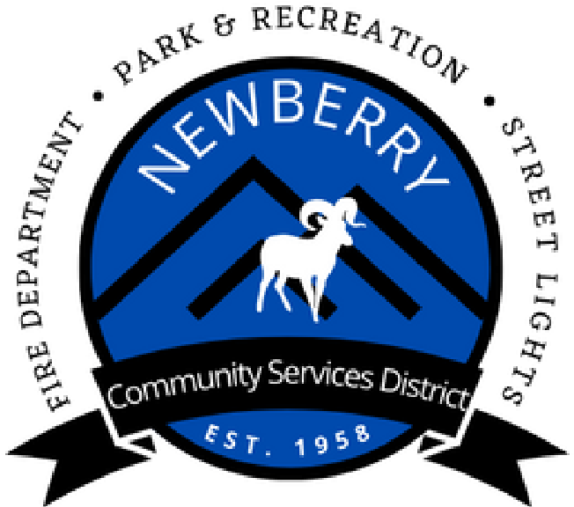

760-257-3613

Newberrycsd.net

30884

Newberry Rd.

Newberry Springs, CA 92365

P.O. Box 220

Newberrycsd@gmail.com

General Manager Report September 24, 2024

1. Stewarts will not do direct deposit for the stipends; they said you must be an employee to get direct deposit.
2. Eide Bailly has made tremendous progress with our books, the audits are reconciled from 2021 to present. They are 90% finished with the credit card reconciliation, payroll liability cleanup is complete. Accounts receivable and payable have been cleaned up, along with revenue/expense accounts and the chart of accounts will been improved. The board approved Eide Bailly to start on our books on February 8th, they quoted us approximately $27,000. The CSD has paid $12,613.43 so far.
3. I attended the General Managers class at the CSDA convention on Sept. 9th. I was able to speak with other GM’s, gain references and leadership skills that will be applied to my role as the General Manager. I enjoyed it and would love to attend more in the future. Director Matson was also there for the entire conference and has things to add.
4. The CSD is sponsoring the Pumpkin Patch this year, it will be held on October 19th 5pm to 8pm at the park.