**AB 992: Open Meeting Laws and Social Media**

**New California Law Addresses Prohibition on Serial Meetings on Social Media**

California public officials could run afoul of the Brown Act if they communicate with legislative members of the same body on social media under the recently enacted [Assembly Bill 992](http://leginfo.legislature.ca.gov/faces/billNavClient.xhtml?bill_id=201920200AB992). Now, even giving a “thumbs up” to another official’s social media post on a topic within the legislative body’s subject matter jurisdiction could violate the law. AB 992, signed by Gov. Gavin Newsom late Friday, is the first amendment to the Brown Act to address public officials’ use of social media.  
   
The Brown Act generally requires that a legislative body’s meetings be open and public, including advance notice, posting of the agenda and accessibility by the public. The Act prohibits a majority of members of a legislative body from engaging in a “series of communications,” directly or through intermediaries, to “discuss, deliberate, or take action on an item” that is within the legislative body’s subject matter jurisdiction.  
   
AB 992, which amends Government Code section 54952.2, clarifies what kind of communications a public official may have via social media and what kind of communications are prohibited.  
   
First, AB 992 clarifies that a public official may communicate on social media platforms to answer questions, provide information to the public or to solicit information from the public regarding a matter within the legislative body’s subject matter jurisdiction. However, the latter types of communications are only allowed as long as a majority of the members of the legislative body do not use any social media platform to “discuss among themselves” official business. According to AB 992, “discuss among themselves” includes making posts, commenting and even using digital icons that express reactions to communications (i.e., emojis) made by other members of the legislative body.  
   
Second, a single contact between one public official and another normally would not constitute a prohibited serial meeting. However, AB 992’s social media prohibitions go further. It prohibits a member of a legislative body from responding “directly to any communication on an Internet-based social media platform regarding a matter that is within the subject matter jurisdiction of the legislative body that is made, posted, or shared by any other member of the legislative body.” Now, if one public official posted a comment in response to another public official’s social media post about an agency issue, that could be a Brown Act violation, assuming the two serve on the same legislative body.  
   
The bill applies to Internet-based social media platforms that are open and accessible to the public. According to the bill, “open and accessible to the public” means “that members of the general public have the ability to access and participate, free of charge, in the social media platform without the approval by the social media platform or a person or entity other than the social media platform, including any forum and chatroom, and cannot be blocked from doing so, except when the Internet-based social media platform determines that an individual violated its protocols or rules.”  
   
AB 992 encompasses activity on many types of social media platforms, including, but not limited to, Snapchat, Instagram, Facebook, Twitter, blogs, TikTok and Reddit. That means it could affect social media commenting, retweeting, liking, disliking, responding with positive or negative emojis and/or screenshotting (photographing) and reposting.

**Unanswered Questions and Practical Considerations**  
Though AB 992 relates directly to the Brown Act, it indirectly touches on other transparency laws. For example, if a public official’s social media comments could lead to Brown Act violations, does that mean that the officials’ posts and comments are now subject to the California Public Records Act and potential disclosure? Do agencies need to retain public officials’ social media posts, particularly to demonstrate whether a Brown Act violation occurred?

The bill may also indirectly affect due process concerns. AB 992 allows public officials to provide information to the public on social media.  If the information that’s posted is how a public official intends to vote on a development project, for example, could an applicant raise a claim that the applicant was denied a fair hearing?   
   
Finally, as more public officials use social media to communicate with constituents and the general public, questions have arisen whether these places have become “public forums.”  AB 992, which sanctions certain uses of social media, could amplify this issue.   
  
*Disclaimer: BB&K Legal Alerts are not intended as legal advice. Additional facts, facts specific to your situation or future developments may affect subjects contained herein. Seek the advice of an attorney before acting or relying upon any information herein.*

[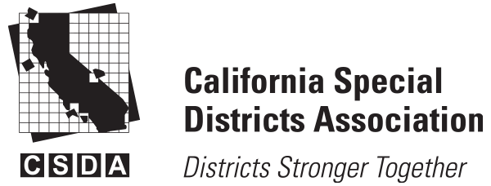](https://www.csda.net/home)

## 2021 New Laws Series, Part 8: The Brown Act Meets Social Media

#### [https://d132x6oi8ychic.cloudfront.net/higherlogic/directory/imagedisplay/5450b4af-8ecd-4c85-aabe-9096816a4531/f1ac741c-1c26-4241-9e44-ea5732bc340e/200/200/638574277848470000](https://www.csda.net/people/kristin-withrow1) By [Kristin Withrow](https://www.csda.net/people/kristin-withrow1) posted 11-30-2020 03:34 PM

## The Brown Act Meets Social Media

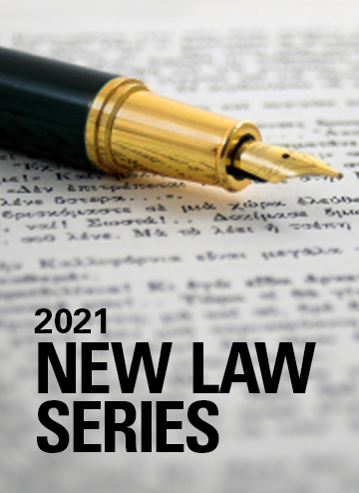***What Public Officials Can and Cannot Post on Social Media Under the Recently Enacted AB 992***

By Hong Dao Nguyen and Albert Maldonado, Attorneys, Best Best & Krieger LLP

Public officials must continue to be vigilant if they post on social media sites about agency-related matters. However, recently enacted legislation, AB 992, aimed at updating the Brown Act to meet today’s social media environment, provides greater guidance for public officials.

Prior to AB 992, public officials across the state received mixed messages and conflicting guidance from their various counsels on what could be posted, “liked,” or shared on Facebook and other social media websites. These conflicting messages sometimes led to paralysis and some public officials avoiding communication on social media. While the public is increasingly receiving their news and community information from social media, some public agency officials have been noticeably absent from that communication medium. AB 992 was drafted and passed in the hopes of providing greater clarity on the actions public officials can and cannot take on social media, thereby encouraging greater communication and transparency with the public.

The Brown Act, a transparency law, generally provides that legislative bodies must have noticed and open meetings to discuss and transact agency business. Until AB 992 was signed into law in September, the Brown Act was silent regarding communications on social media.

AB 992 amends Government Code section 54952.2 and clarifies that a public official may communicate on social media platforms to answer questions, provide information to the public or to solicit information from the public regarding a matter within the legislative body’s subject matter jurisdiction. But those communications are only allowed if members of the same legislative body do not use a social media platform to discuss official business among themselves. “Discuss among themselves” means making posts, commenting, and even using digital icons that express reactions to communications (i.e., emojis) made by other members of the legislative body.

Notably, AB 992 is stricter about social media contacts between public officials than in-person contacts. For example, under the Brown Act, two public officials of the same agency could talk face-to-face about a public agency matter without running afoul of the law. However, AB 992 prohibits a member of a legislative body from responding “directly to any communication on an Internet-based social media platform” regarding an agency matter if the communication is “made, posted, or shared by any other member of the legislative body.”

Questions are already arising regarding what social media communications are now allowed under the law. The following includes some questions and answers to unpack AB 992:

**Question**: To what kinds of social media platforms does AB 992 apply?

**Answer**: AB 992 applies to Internet-based social media platforms that are “open and accessible to the public.” “Open and accessible to the public” means “that members of the general public have the ability to access and participate, free of charge, in the social media platform without the approval by the social media platform or a person or entity other than the social media platform, including any forum and chatroom, and cannot be blocked from doing so, except when the Internet-based social media platform determines that an individual violated its protocols or rules.”

Practically, those platforms include, but are not limited to, Snapchat, Instagram, Facebook, Twitter, blogs, TikTok and Reddit. That means AB 992 could affect social media commenting, retweeting, liking, disliking, responding with positive or negative emojis and/or screenshotting (photographing) and reposting.

**Question:**Does AB 992 prohibit public officials from commenting, sharing, or liking a social media post that was posted by the public agency on its own social media platform?

**Answer:** No, AB 992 does not prohibit a public official from commenting, sharing, or liking a social media post that was posted by the official’s public agency. For example, if a public official wants to share his or her agency’s post about water conservation, the official could still do that. AB 992 expressly allows a public official to communicate on social media platforms to answer questions, provide information to the public or to solicit information from the public regarding a matter within the legislative body’s subject matter jurisdiction.

An issue may arise, however, if one director shares his or her agency’s post on water conservation, and another director from the same board gives it a thumbs up. That would likely be a prohibited direct communication on social media.

**Question:**What if Director A posts about an agency matter, a member of the public then comments on the post, and then Director B replies to the public comment?

**Answer**: It is unclear whether the above scenario would violate AB 992. On one hand, Director B would likely claim that he or she is directly communicating with a member of the public and not Director A. On the other hand, someone could claim an AB 992 violation since the thread was started by Director A.

An important takeaway here is that whether or not a violation of AB 992 has occurred will likely be driven by the facts. For example, what if Director A started the thread and there were 10 intervening replies or comments before Director B chimed in? Could Director B’s reply still be categorized as a “direct communication” to Director A? A conservative approach is for public officials to avoid posting on threads in which another public official of the same agency has posted, if the issue relates to public business. This is especially true if two directors have already commented on a public agency-related thread, since a third director’s input could constitute a serial meeting by a majority.

**Question:**What if Director B shares or retweets Director A’s post without comment?

**Answer:**Some social media platforms like Facebook and Twitter allow users to “share” someone else’s post or “retweet” a post, respectively. Arguably, if one director is taking another director’s post about a public agency matter and posting it onto his or her own page — even without comment — that would appear to be a direct response. Typically a share or retweet of another person’s post shows support of that post (though that’s not always the case).

Similarly, if two other directors (Directors B and C) shared or retweeted Director A’s post — even without comment — those directors would appear to be a majority of the body “discussing among themselves” a topic within their agency’s purview.

**Question**: Can public officials use social media to discuss personal matters amongst themselves?

**Answer**: Yes. Neither the Brown Act nor the new provisions in AB 992 prohibit discussions regarding private matters. For example, there is no issue with one director giving a thumbs up to another director’s family photo or a majority of directors congratulating another director for finishing a marathon. The Brown Act only applies to public agency business.

**Question:**How would AB 992 be enforced?

**Answer:** AB 992 does not include any new or additional enforcement provisions. The district attorney or any interested person could raise a claim that a public agency violated the Brown Act and follow the enforcement provisions provided in the Government Code.

**Question:** Does AB 992 affect other methods of communication, such as public officials texting or emailing one other?

**Answer:** No, AB 992 only applies to communications about agency business on social media accounts that are generally open to the public.  It does not regulate other electronic means of communication such as text messaging or emailing.  However, the other means of electronic communication could raise other issues, including serial meetings and the California Public Records Act.

**Question:** How does AB 992 implicate the California Public Records Act?

**Answer:**In the case San Jose v. Superior Court (2017) 2 Cal. 5th 608, the California Supreme Court held that communications on personal electronic accounts could be subject to the Public Records Act. If public officials are using social media to communicate with members of the public (or one another), those posts could be subject to the Public Records Act.

As noted, whether an issue has arisen under AB 992 is highly factual, and this article only gives a sampling of the questions that may come up with public officials’ use of social media. For specific issues, public officials should consult with their agency’s general counsel.

This article was written by, Hong Dao Nguyen and Albert Maldonado Attorneys, Best Best & Krieger LLP, as part of CSDA’s New Laws Series, where experts explain recently enacted laws and how they will impact special districts moving forward. This article is provided for general information only and is not offered or intended as legal advice. Readers should seek the advice of an attorney when confronted with legal issues, and attorneys should perform an independent evaluation of the issues raised in these materials.

**7191 views**

[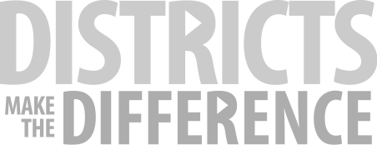](https://www.districtsmakethedifference.org/)

Copyright © 2024 CSDA. All Rights Reserved.

Site by [eConverse Media](http://econversemedia.com/" \t "_blank).