5‑Meeting Community Design Series – Facilitator Packet
Field guidelines for park engagement: objectives, activities, materials, and outputs for each meeting.

Master Checklist – Applies to Every Meeting
- Accessible venue & timing (evening/weekend); ADA seating & routes; childcare; light food.
- Multilingual: flyers, slide deck, agendas, interpreters; translated surveys & comment cards.
- Data capture: sign‑ins (demographics optional), consented photos, table notes, QR survey link.
- Online mirror: Zoom or recording + online survey for those who can’t attend.
- Documentation within 7 days: one‑page recap, ranked results, and “You Said → We Did” update.
- Procurement‑friendly filekeeping: agendas, sign‑ins, photos, handouts, copies of all materials.

Meeting 1 — Listening & Needs Assessment
Goal: Understand who we serve, barriers to access, and desired outcomes.

Core Activities
- Welcome; project 101; ground rules.
- Baseline needs survey (paper + QR).
- Small‑group story mapping: current park use, gaps, barriers (safety, shade, ADA, transit).
- Barrier mapping on large area map (heat, flooding, lighting, crossings).

Materials Checklist
□ Multilingual flyers/agendas/sign‑ins; interpreters.
□ Large area map; sticky notes; markers.
□ Needs survey (paper + QR) and comment cards.
□ Consent cards for photos; table tents for languages.

Room Setup
- Round tables for small groups; one large map station.
- Clear ADA routes; quiet table for sensory needs.

Staffing Roles
- Facilitator (room lead); 1 notetaker per table; interpreter; greeter/sign‑in lead; photographer (with consent).

Expected Outputs (Leave With)
- Ranked Needs Summary (top 5 needs; top 5 barriers).
- Attendance counts and participation demographics (optional).
- Photo log and scan of all written feedback.

After‑Meeting Follow‑Up (Within 7 Days)
- Compile needs survey results; theme coding.
- One‑page recap sent to list; post online.
- Schedule posted for Meeting 2 with preview of needs ranking.

“You Said → We Did” Commitment
- Publish ranked needs list before Meeting 2 and note any immediate adjustments to scope.

Meeting 2 — Amenities & Program Mix
Goal: Translate needs into activity and amenity priorities by age, ability, and culture.

Core Activities
- Recap results from Meeting 1 (You Said → We Did v1).
- Amenity card exercise (e.g., shade, play types, sports, fitness, lighting, restrooms, art, habitat).
- Dot‑vote or budget tokens (each person allocates limited points).
- Equity check: inclusive play, ADA routes, sensory/quiet spaces, multigenerational seating.

Materials Checklist
□ Amenity cards with icons; rough cost tiers ($/$$/$$$).
□ Voting dots/tokens; tally sheets.
□ Youth table activity; bilingual aides.

Room Setup
- Stations by theme (Play, Courts, Nature, Gathering).
- Large wall for live tally board.

Staffing Roles
- Facilitator; station leads; data tally lead; interpreter; youth facilitator.

Expected Outputs (Leave With)
- Ranked amenity list with narrative rationale.
- Draft program mix: must / should / could.

After‑Meeting Follow‑Up (Within 7 Days)
- Publish ranked amenities + what rose/fell and why.
- Email/post recap and invite to Meeting 3 (layout charrette).

“You Said → We Did” Commitment
- Show how amenity rankings directly inform layout options for Meeting 3.

Meeting 3 — Site Layout & Placement (Design Charrette)
Goal: Place amenities on site and test circulation, safety, shade, and access.

Core Activities
- Recap amenity priorities.
- Hands‑on charrette with scaled base maps and moveable cutouts.
- Overlay analysis: sun/shade, trees, slopes/drainage, CPTED sightlines, noise, ADA routes, transit/parking.
- Identify conflicts/tradeoffs; capture pros/cons of 2–3 alternatives.

Materials Checklist
□ Base maps (1"=20'); tracing paper; foam/paper cutouts; tape; markers.
□ Legends for lighting, trees, water, play, quiet zones.
□ Camera or overhead scanner for capturing layouts.

Room Setup
- Tables by alternative; wall space for posting concepts.
- Wayfinding signs; accessible circulation in room.

Staffing Roles
- Lead designer; table facilitators; notetakers; interpreter; documentation lead.

Expected Outputs (Leave With)
- 2–3 concept alternatives (photos/sketches).
- Pros/cons list; draft ADA access route.

After‑Meeting Follow‑Up (Within 7 Days)
- Create alternatives packet (PDF) to share before Meeting 4.
- Short video/slide recap for social media.

“You Said → We Did” Commitment
- Publish alternatives with notes on how Meeting 2 priorities shaped them.

Meeting 4 — Costing, Tradeoffs & Phasing
Goal: Select a preferred concept with realistic costs, O&M, and phases.

Core Activities
- Present ROM costs (base + add‑alternates) and O&M implications.
- Small‑group scoring against criteria: safety, equity, access, environment, cost, maintenance.
- Phasing exercise: Phase 1 (grant scope), Phase 2 (future), quick wins.

Materials Checklist
□ Cost cards per element; maintenance icons (low/med/high).
□ Score sheets; criteria posters; stickers.
□ Funding notes (SPP/LWCF/local).

Room Setup
- Board displays for each alternative + cost overlays.
- Tables by criteria; clear route to vote/score stations.

Staffing Roles
- Facilitator; cost analyst; maintenance/PW rep; interpreter; scribe.

Expected Outputs (Leave With)
- Preferred concept identified; Phase 1 scope list (grant‑ready).
- Phased budget tiers; draft O&M bullets.

After‑Meeting Follow‑Up (Within 7 Days)
- Publish chosen concept and rationale; list items moved to future phases.
- Prepare draft concept board for Meeting 5.

“You Said → We Did” Commitment
- Show how costs and maintenance shaped the preferred plan.

Meeting 5 — Final Concept, Commitments & Next Steps
Goal: Confirm final plan; document community support; outline approvals and grants.

Core Activities
- Present refined final concept boards/renders; accessibility narrative.
- Open comment; collect letters of support; volunteer/stewardship sign‑ups.
- Explain schedule: CEQA/NEPA path, permits, grant submittals, construction window.

Materials Checklist
□ Large display boards/renders; comment forms; support letter templates.
□ Contact sign‑up sheets; QR to final packet.
□ Interpreter headsets; podium mic if available.

Room Setup
- Open house/gallery layout; accessible seating and line of sight.
- Welcome table for letters/sign‑ups.

Staffing Roles
- MC/facilitator; designer; interpreter; documentation lead; volunteer coordinator.

Expected Outputs (Leave With)
- Final Concept Report (plans, phases, costs).
- Engagement Appendix (sign‑ins, surveys, photos).
- Final “You Said → We Did” summary.

After‑Meeting Follow‑Up (Within 7 Days)
- Distribute the Final Concept Report (PDF + print).
- Email packet to attendees; post to website; archive materials.

“You Said → We Did” Commitment
- Release the final 'You Said → We Did' summary and thank-you message.

Appendix – Quick Templates to Bring
- Sign‑in sheet (with optional demographic checkboxes).
- Comment card (open-ended + contact opt‑in).
- QR code survey link (paper copies available).
- Amenity cards and cost tiers.
- Support letter template (Meeting 5).

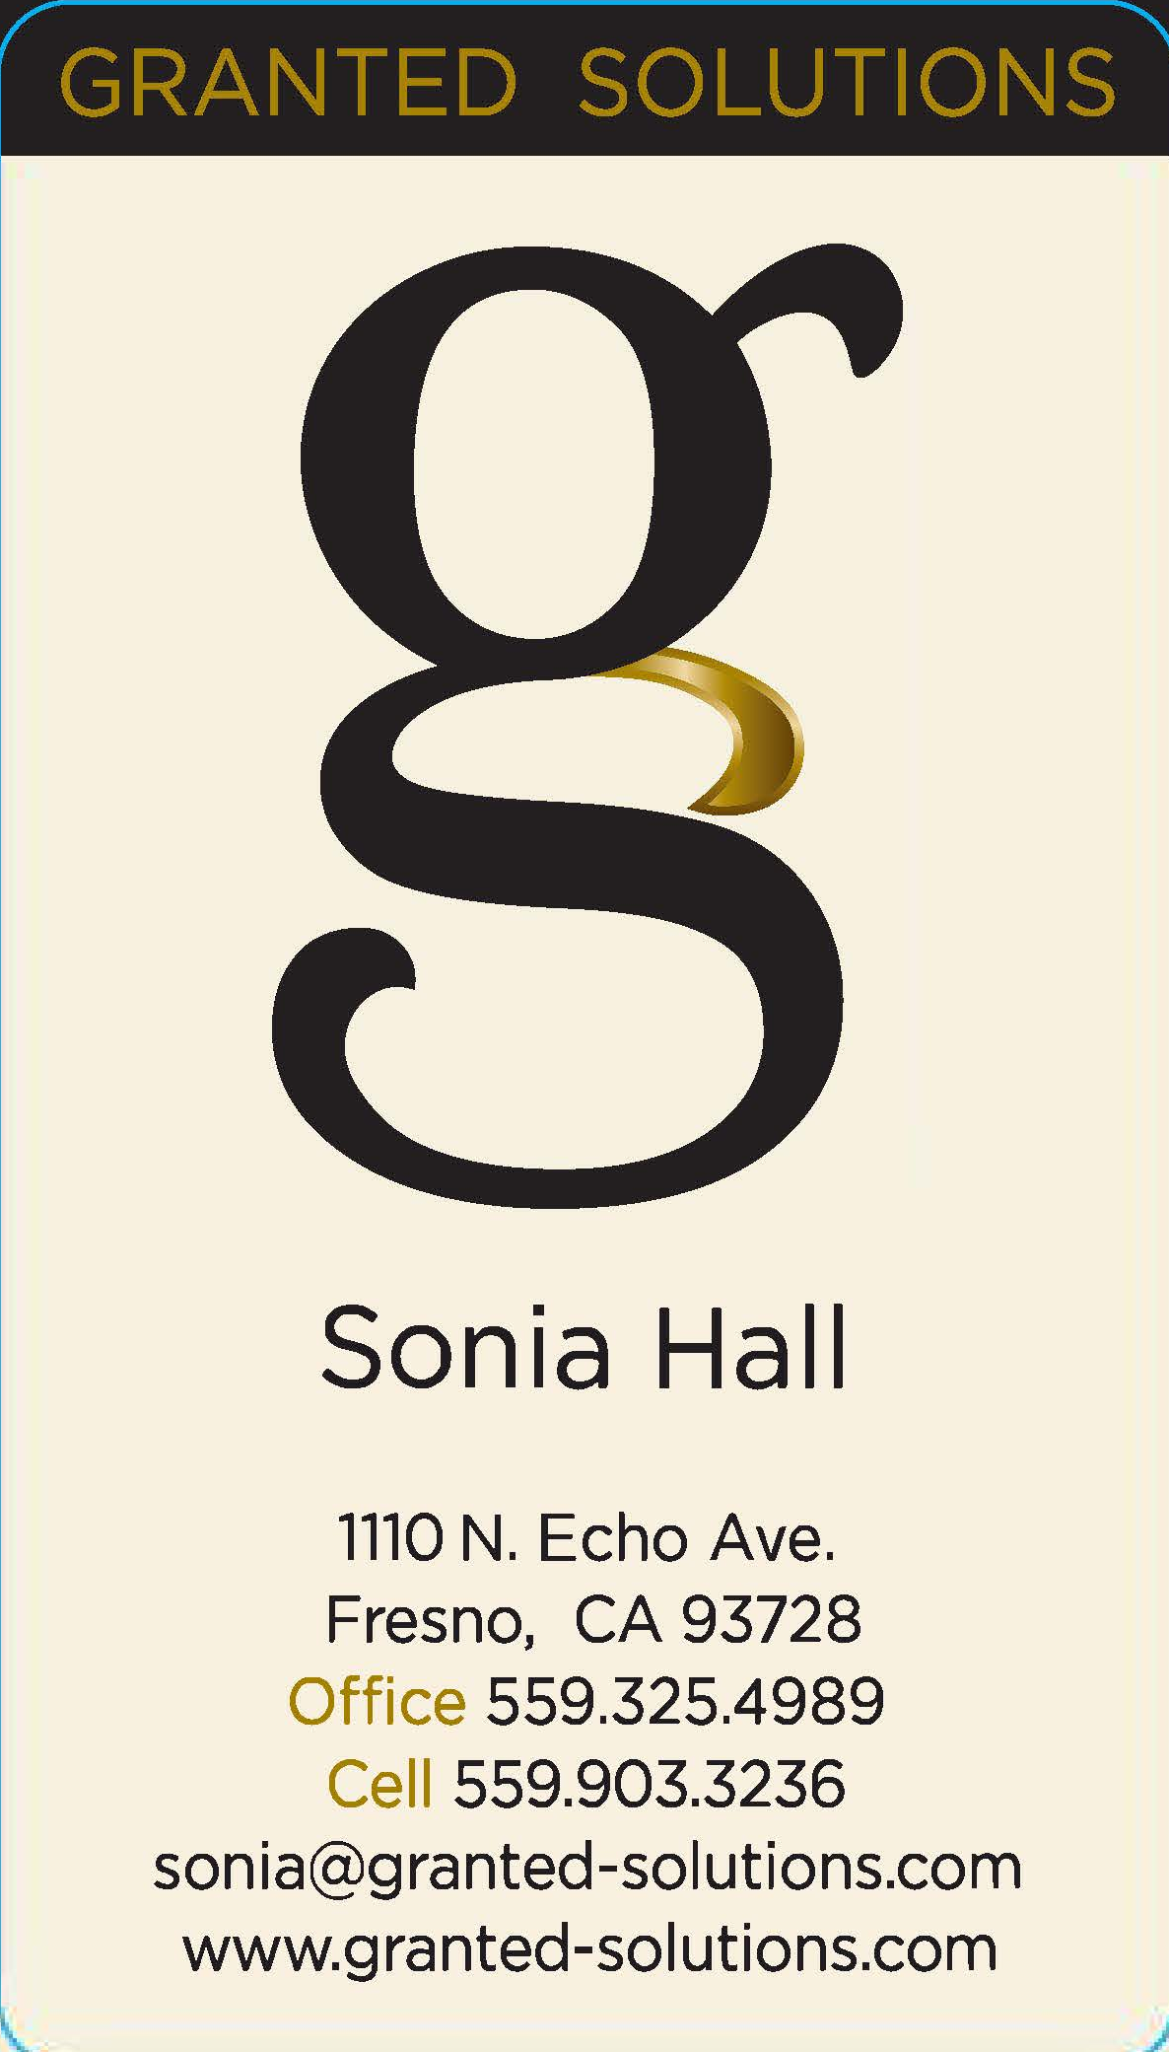

Contact Sonia Hall if you need any support.

